**Design Spec**

**Re-vamping conferences**

Conference screen:

* There will only be two side conversations. On the bottom, the main conference will be in the middle with side conversations on the left and on the right.
* Audio from conversations that you are not currently in are spatialized. If I am in the main and have two side chats, I will hear one side chat on my far left and one on my far right. These will be a single point sound. If I am in the left side chat, then I should hear the main conference on my far right, and the right side chat on my farther right.
* We will retain the ability to hear two conversations at once. The one that you are not in will be at a lower volume. We no longer need the volume panel displauyd.
* Whoever is speaking will have a yellow "halo" highlight to his/her icon.
* Whichever conversation the user is in will have the same yellow border.
* Change side chat to side conversation.
* Side conversation icons will have a light grey background and the main icon will have a dark grey background. The main icon will no longer say “main” and instead have squares like the other icons.

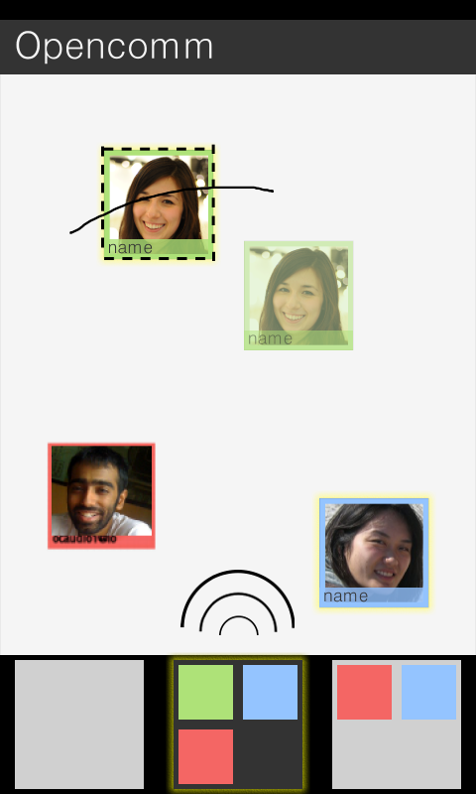

Figure 1. New conference screen and side chat. After the user draws a line through the icon(s) and drags it, the ghost icon will appear.

Side conversation:

* We will have a sort of lasso mechanism for adding people to side conferences. Anytime the user touches his finger to a blank area and drags, it will start drawing a line. If that line goes through any of the icons, it should appear behind the icon, but the icon should fade into a “ghost.”
* After the lasso has been triggered, clicking on any blank area will get rid of the effect. Clicking and dragging will instead continue the operation to the user can highlight more icons.
* After the lasso has been triggered, clicking an icon and dragging it to a side conversation will add all of the highlighted icons to that side conversation. The dragged item should be the ghosts of all the highlighted icons cascaded, and upon dragging the original icons should be revealed. So only the “ghosts” move.
* While the user is dragging icon(s), the lasso and line drawn through the icon will remain
* If the user either releases the ghost icon or adds the icon in a side conversation, the lasso and line will disappear
* Even if the user is adding multiple users into a side conversation, only one icon in the group needs to be dragged into the side chat icon for all of them to be added into the side conversation
* Remove side chat preview. Tapping on a side conversation icon should just take you there.

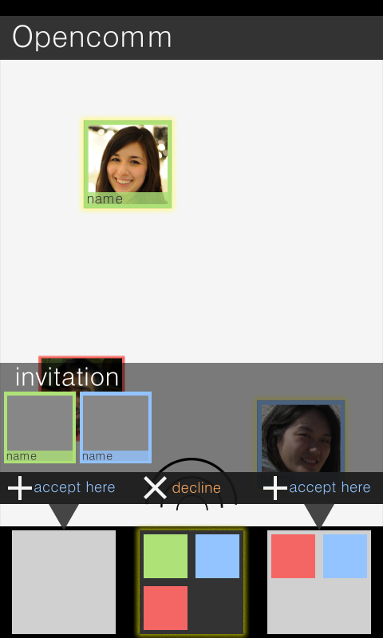

Figure 2. Invitations to a side conversation. A minor error in the image is how the leftmost side conversation is empty. This invitation should only show up if both side conversations are occupied.

Invitations (to side conversation):

* Invites will now be in the form of the preview bar we currently have.
* Put the title "invitation" on top.
* The bottom of the invite will have pointers to the two side conversations. On top of the pointers will be the button "accept here" so that the user can choose which conversation will be destroyed. In the middle will be a “decline” button.

Backlog items to complete if the UI team has more time (please notify us so we can spec these things in detail): auto spacialization of icons, grouping people into same the point, tagging people in the same group, error screens/handling, different screen resolution